**Final Prototype:**

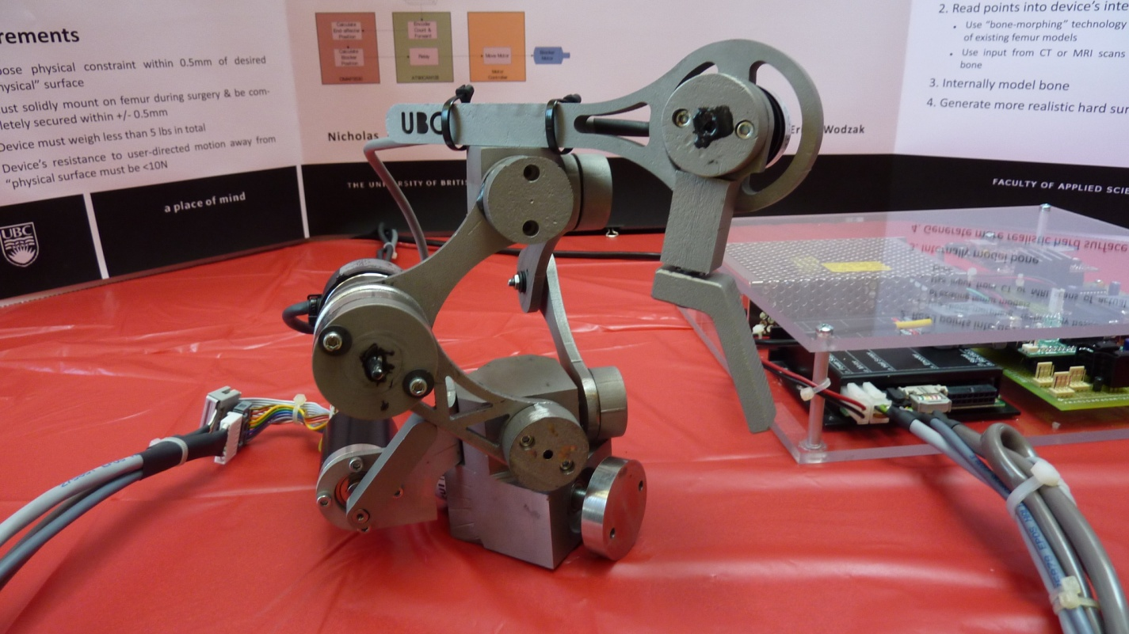

**Prototype Testing Expectations**

1. *Precision & Accuracy:*

During our demo, we presented the capability of the prototype to read from the primary link encoder, simply as a proof to the functionality of the control system. With all three encoders being read, the theoretical precision of the device is very high, since the mathematical relationships derived for the tool position are accurate. However, if we used our prototype for precision testing, the play in almost all the joints and connections would overthrow the precision of the encoders and the correctness of our theoretical relations. We would expect a very accurate motor (hard constraint) placement, but when the device contacts the hard constraint, it would sag and skew about 2 or 3 mm.

*Solution:* This problem can be solved with a number of improvements in the prototype. The main improvement would be the precision of the machining. If all the parts are made accurately to scale and within the tolerances of the CAD drawings, much less play will be present in the joints. This type of accuracy is only attainable through CNC or computer-aided machining. In addition, if a lighter material is used, less sag will occur because the load on the non-constrained side will be much less. There are two possible solutions – use a lighter material or put a second hard constraint on the other joint. We believe using a lighter material would be a smarter choice, because it will help avoid complicated synchronization and calibration of two hard constraints.

1. *Workable Area:*

Our prototype has proven that the workable area capability of the design is very impressive. When compared to the “real-size” foam knees which we purchased, it quickly became clear that our prototype actually reaches full knee replacement surgery sizes quite easily. Using its full range of motion, the design we proposed has a very satisfactory workable area, thus, no further development or improvements are needed in this area.

1. *Hard Surface (& Instability):*

As it has been previously explained, the machining quality and sheer weight of our prototype rendered it useless for almost any meaningful testing results. The hard surface test is the most important test of the robot, but couldn’t be preformed because the sag, play and weight of the robot made it inoperable. However, with the proposed improvements below, we would expect that the hard surface emulation would be successful. It is worth noting that the *placement* of the hard constraint motor (and the hard constraint itself) can have a strong effect on the responsiveness of the hard constraint. As shown in the picture below, the current prototype has the hard constraint almost always perpendicular to the primary link t acts on. As we realized later on, this motor placement setup made it even more difficult for the constraint to move under load. Also, due to the contoured shape of the primary link, it added another difficulty in the required mathematical calculations for where the constraint should be (in specific, nonlinearity). Thus, we would propose a motor placement where the hard constraint can somewhat follow the primary links while being parallel to them, not perpendicular. Also, the primary link edge which is in contact with the hard constraint should be straight.

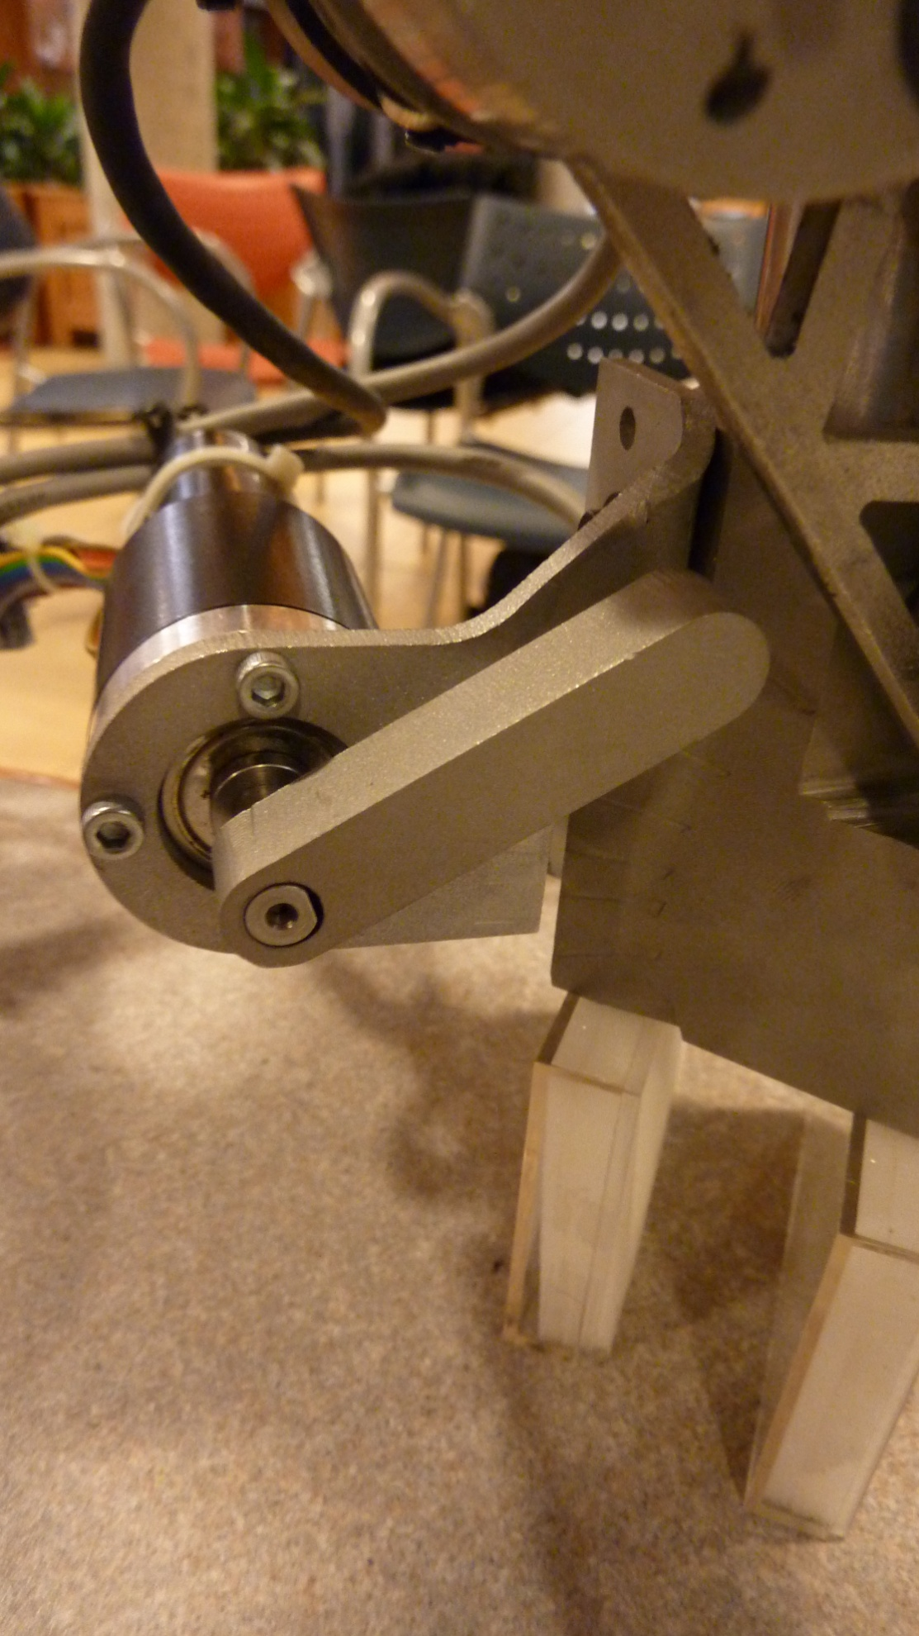

Primary Link

Hard Constraint

Hard Constraint Motor

*Solution:* With regards to the hard surface, the main improvement would be the motor placement, as described in the paragraph above. However, machining quality and device weight will also have a very big impact on the robot’s ability to emulate a hard surface – or more specifically, it will help the user be able to use the device properly, because, as of now, it is too heavy and difficult to control.

1. *Virtual Weight:*

Although the overall weight of the device is below the functional requirement we set in the beginning, the virtual weight of the device is unacceptable. The weight the user feels or resists while using the device, or virtual weight, was expected to be higher than our limits, and it definitely was. There is only one reason for this: material choice. Since we were hoping to create a prototype usable in cadaveric testing, we chose a medical grade material (stainless steel). In order to machine our parts, we chose a machinable grade (303). Making everything out of 303 SS tripled our device’s weight if compared to an exact replica made out of aluminum. In fact, we believe that if we were to use aluminum for the prototype, we could have had a fully functional device at an earlier date, because the time it would take to machine all the parts would be drastically reduced.

*Solution:* Use a lighter material (such as aluminum) to prove the design’s overall functionality, then, if successful, use high-end materials which are both lightweight and medical grade, such as titanium, to make a prototype which can be used in cadaveric testing.

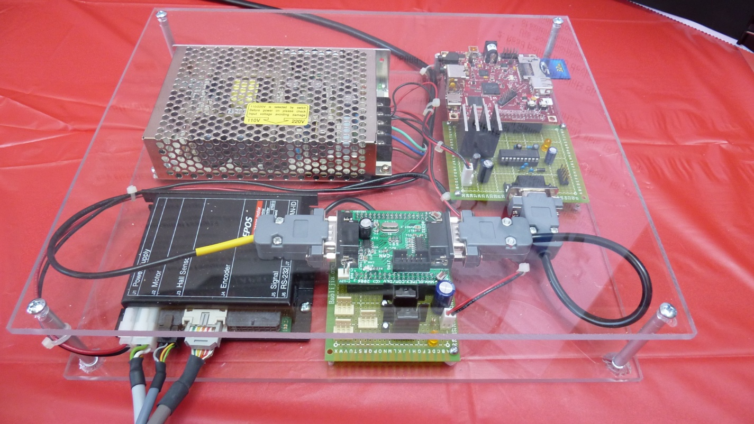

1. Update Speed

With regards to the 1 kHz update speed requirement, the system currently falls short by 100Hz due to (1) AVR-CAN RS232 interface only being able to function at 57600 baud and (2) the data being sent from the Beagleboard is too large to transmit at 1 kHz at that speed. Even though the system can only run at 90% of the update speed requirement, the system retains its functional requirements in most cases. After further analysis of the encoder position tracking on the AVR-CAN microcontroller, there may be cases where the update speed is severely reduced and may cause skipping in the position tracking. This may occur when a change in position of the end-effecter changes the positions of all three encoders at the same time.

*Solution:* If using the same setup, one solution to the update speed in the interface would be to reduce the transmission of unnecessary data (bits). Using a dedicated quadrature counter or a microcontroller with dedicated circuitry for quadrature encoders will eliminate possible update speed problems.